**Assignment 1 – Centralized COP**

Uriel Zaed 319435608

Ran Weissman 312236466

We created a random COP which receives 4 parameters:

N - 8

D – 8

P1 – 0.4 / 0.7

P2 – 0.1 – 0.9

We implemented 3 algorithms:

1. B&B
2. B&B with FC
3. B&B with heuristics – The heuristic implement:

* Variable sort
* Domain sort
* Random initial solution cost

We created 10 problems for every COP case and applied the three algorithms to solve them. The subsequent findings illustrate the average number of constraint checks (CCs) for comparison.

Results of p1 = 0.4

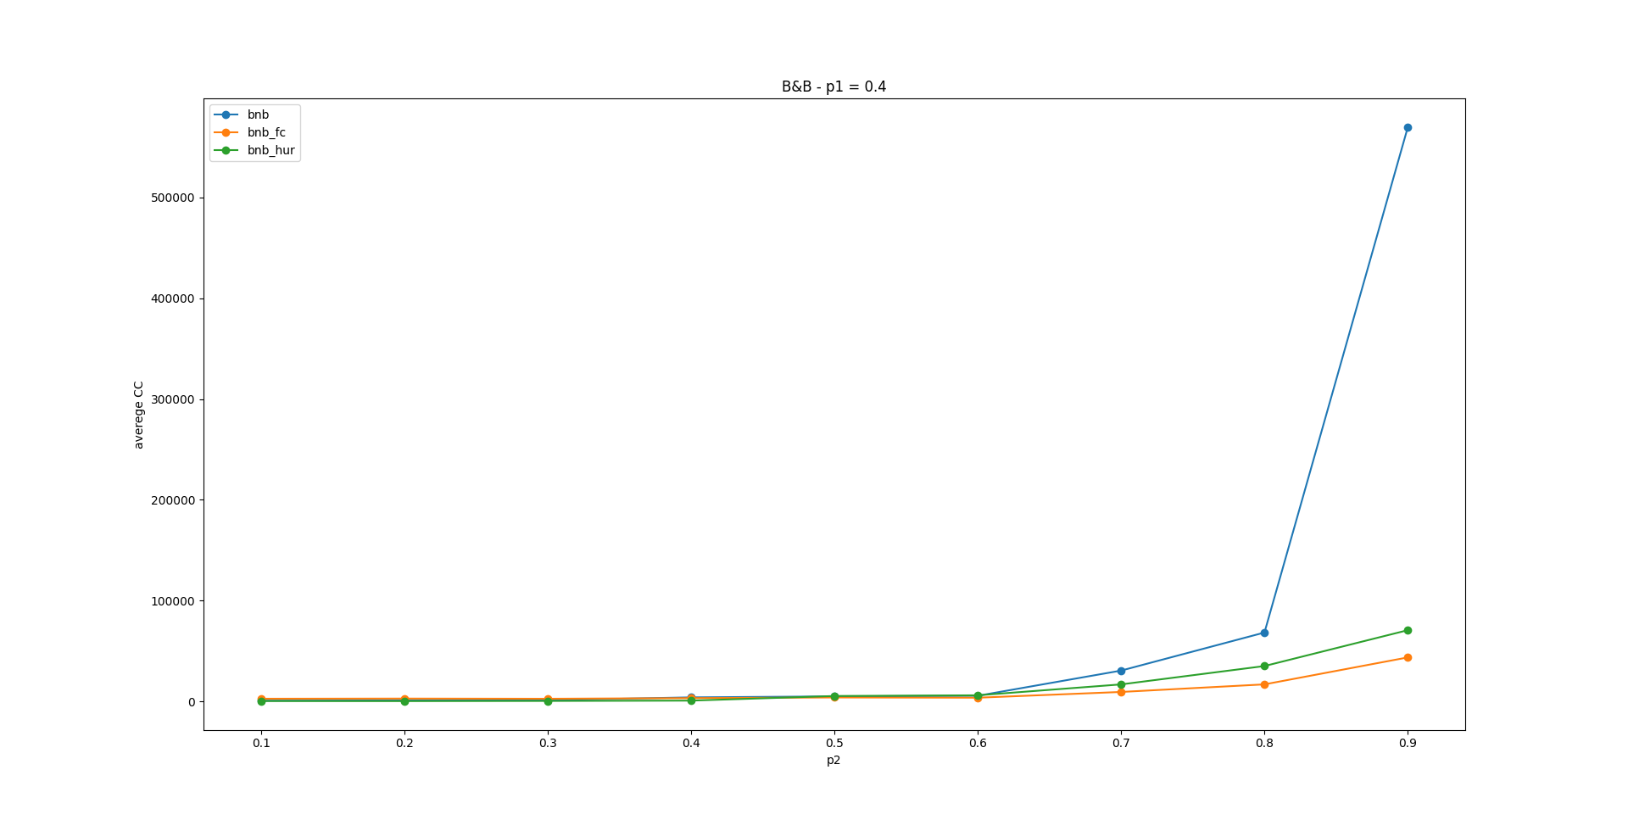

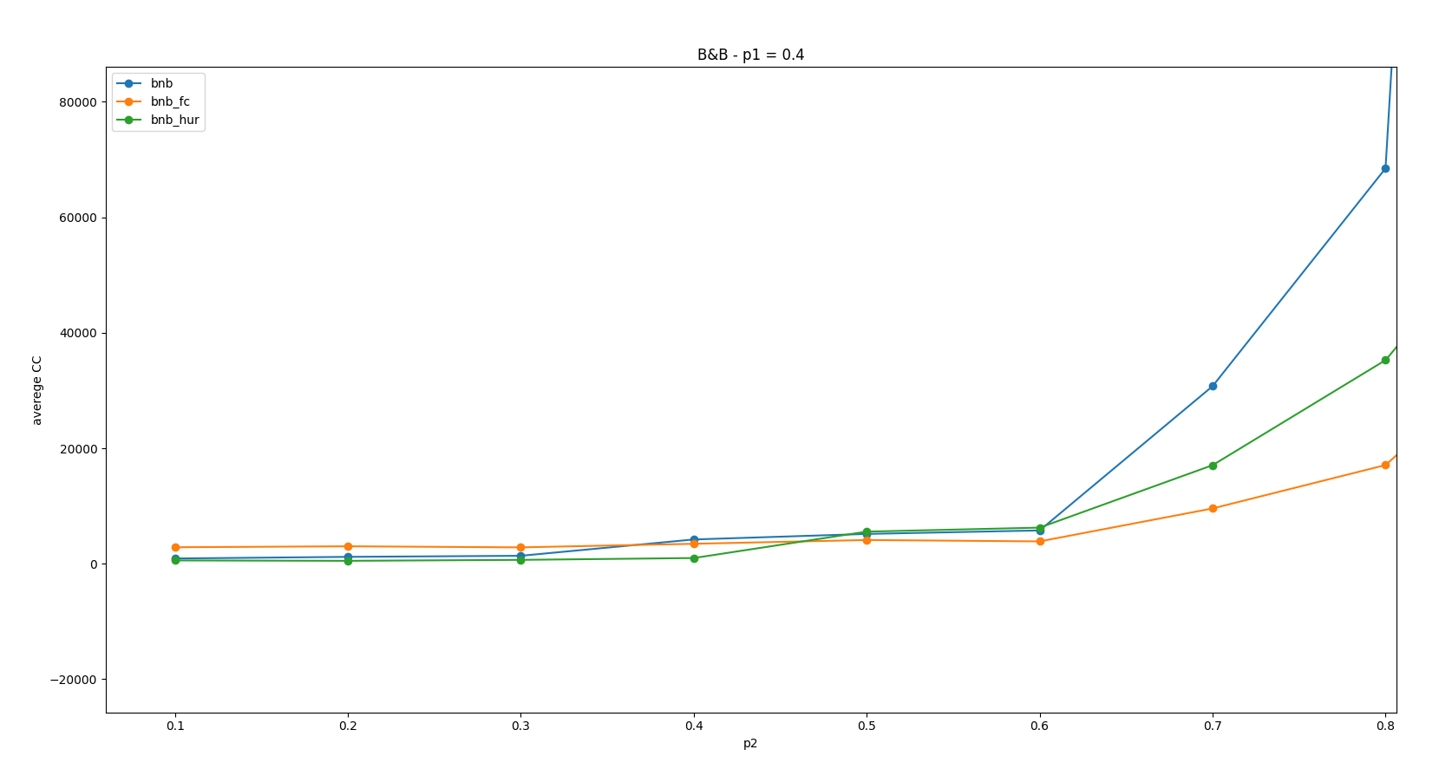

Results of p1 = 0.7

